8. Write a java script page to find the
• Exponential value.
• Limit the number of digits after the decimal value.
• Convert a number to string.
• Return negative infinity using the number object in the HTML document. 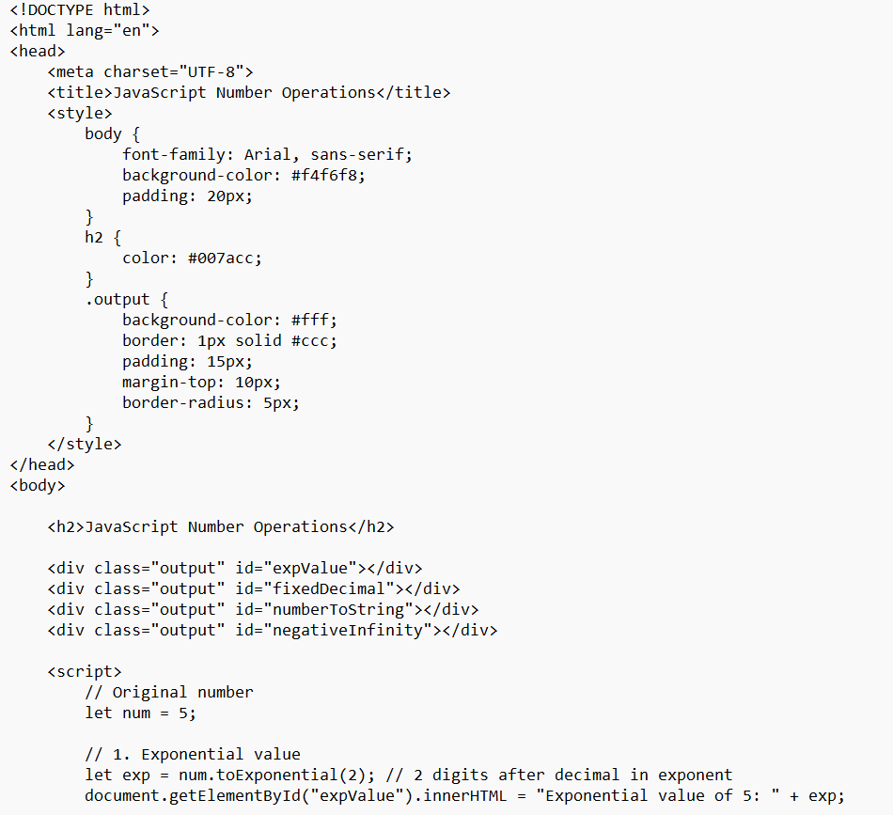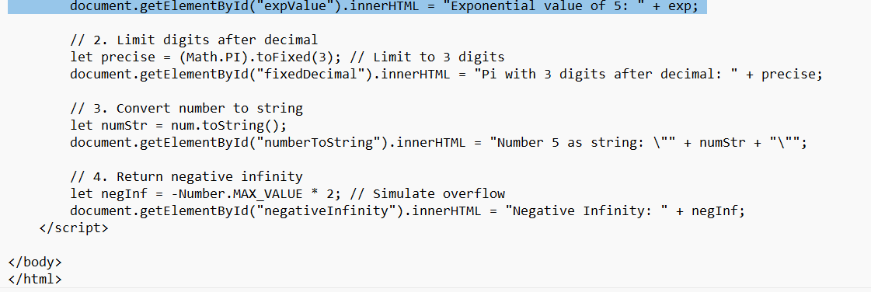output
